- 4.1.3.2:
- Could you kindly specify what are the acceptable options for having date and time stamp on media clip?
- We suppose that burnt-in human-readable timecode on the video itself would be not necessary?
- Would you accept keeping date and time as metadata field of an asset in Media Asset Management system?

RFP Answer:
The intended point was not burnt-in timecode but the time-code and date embedded within metadata of the media clip to “allow time reference of its creation”.

4.1 | Technical Information
The core server and ingest equipment will be installed in the News Server Room on the 3rd floor of the News Block; racks for installation are available.
The equipment for video editing and the studio playout will be installed on the 3rd floor in the edit suites and the studios, respectively.
Some of the News Facilities have already migrated to HD (1080i/25 and/or 1080i/50).
The SABC is in the process of migrating to ST2110.
4.1.3 | The solution needs to accommodate the SABC’s in house station time code which is required to:
4.1.3.2 | Scheduled and manual ingests require a date and time stamp on each new media clip to allow time reference of its creation. |  | 2 | 2

- 4.2.1:
- Do we understand correctly that this requirement (and the entire section 4.2) is related to storage (i.e. NAS) and not to other system components running on servers?

Also refer to Question 3) RFP Answer and Question 30) RFP Answer
RFP Answer: Section 4.2 is Core Storage - refers to Media Storage
4.2.1 which needs to be scalable, i.e. if the system requires additional storage of 1000 Hours of content or the addition of another 4 ingest ports on the Ingest storage we must be able to purchase the storage and additional ingest inputs ports/cards as the upgrades are required.

We are referring to a Live Media Production System with Live content ingested directly onto the storage not necessarily via Network Attached Storage (NAS), as one of the core requirements is to be able to view and edit the ingested content by any of the NPS editing systems after 20 seconds of recording as the note in section 4.3.4.
4.3.4 “Access to live content for editing and playout while ingesting, i.e. the content is ready for editing and playout 20 seconds after the start of the ingest as recording continues.”
4.2 | Core Production Storage
4.2.1 | The core solution must be scalable (ability to expand when required). |  | 5 | 5

4.3 | Content capture/Ingest
4.3.1 | 16x Simultaneous live media recordings (12x controlled by Line Record and 4x controlled by the Studios) |  | 10 | 10
4.3.4 | Access to live content for editing and playout while ingesting, i.e. the content is ready for editing and playout 20 seconds after the start of the ingest as recording continues. |  | 20 | 20

- 4.2.2:
- Do we understand correctly that 2000hours*100mbit/sec=90TB of files capacity should be distributed among all 16 channels of recording?
- Or each recording server should have 90TB of space in local cache?
- Or should it be a separate NAS where ingest servers will be pushing recorded content? Please, clarify this point.
Also refer to Question 2) answer & 31) answer
RFP Answer:
According to 4.2.2 “The core ingest server requires a minimum of 2000 hours of work-in-process HD media content at MXF OP1a AVC-Intra100”.
The RFP is clear on the functional requirements as the system is a Live Media Production System as mentioned above with direct ingest into storage:
4.3.1 “16x Simultaneous live media recordings (12x controlled by Line Record and 4x controlled by the Studios)”
This refers to both High-resolution (AVC-Intra100) and Proxy resolution.
4.3.4 “Access to live content for editing and playout while ingesting, i.e. the content is ready for editing and playout 20 seconds after the start of the ingest as recording continues.”
This allows a playout to be done through the ingested system after 20 seconds and instant access to edit after 20 seconds. We requested our standard on the storage to be AVC-Intra100 as mentioned in 4.2.2
4.3 | Content capture/Ingest
4.3.1 | 16x Simultaneous live media recordings (12x controlled by Line Record and 4x controlled by the Studios) |  | 10 | 10
4.3.4 | Access to live content for editing and playout while ingesting, i.e. the content is ready for editing and playout 20 seconds after the start of the ingest as recording continues. |  | 20 | 20
4.2 | Core Production Storage
4.2.2 | The core ingest server requires a minimum of 2000 hours of work-in-process HD media content at MXF OP1a AVC-Intra100. |  | 40 | 40
4.2.3 | The dual mirrored Playout Storage each requires a capacity of approximately 400 hours (600 x 5min stories – 7days, 20 x 30min Current Affairs stories each week and 50 hours for promos and logos); |  | 20 | 20
4.2.5 | High- and Low-Resolution media is key for multiple editing sessions – the solution must accommodate low and high resolution editing capability according to the network bandwidths; (indicate the formats recommended) |  | 6 | 6

- 4.2.4 and 4.2.6:
- Do we understand correctly that this point is related to storage system only and not to other system components and applications, running on servers or virtual machines?

RFP Answer:
Section 4.2 is Core Storage – i.e. the Media Storage
4.2.4 “Resilience for the solution is core – there should be no single point of failure”
Resilience of the solution is critical or “core” and does impact .
4.2.6 “Each individual server must be able to run stand-alone”.
The RFP request (4.2.3) two (Dual) Playout servers that are mirrored with the same content for resilience. Should one Playout Server fail or be taken down for maintenance the other (4.2.6) individual Playout-Out server needs to run stand-alone to sustain on-air operations.
4.2 | Core Production Storage
4.2.2 | The core ingest server requires a minimum of 2000 hours of work-in-process HD media content at MXF OP1a AVC-Intra100. |  | 40 | 40
4.2.3 | The dual mirrored Playout Storage each requires a capacity of approximately 400 hours (600 x 5min stories – 7days, 20 x 30min Current Affairs stories each week and 50 hours for promos and logos); |  | 20 | 20
4.2.4 | Resilience for the solution is core – there should be no single point of failure |  | 6 | 6
4.2.5 | High- and Low-Resolution media is key for multiple editing sessions – the solution must accommodate low and high resolution editing capability according to the network bandwidths; (indicate the formats recommended) |  | 6 | 6
4.2.6 | Each individual server must be able to run stand-alone. |  | 4 | 4

- 4.3.5:
- We are not entirely sure about this requirement. Does it mean that recording port must be free for other recordings after running recording is terminated?
- Or does it mean that file must be of planned duration, even if recording stopped earlier, with extra frames in the end of the file filled with black frames?
- Please, we’d appreciate if you could elaborate on this question.

RFP Answer:
4.3 “Content capture/Ingest”
4.3.5 “The ability to retrieve unused hours when a recording is terminated. “
The recording port must be released - recording port must be free for other recordings after a recording is terminated,
If a scheduled recording of an hour is done (the system normally reserves the space for the recording and locks the port used for the recording for the dedicated task but if the recording is terminated at 30 minutes the system needs to reallocate the remaining storage for use and readjust the used storage space to 30 minutes and release/unlock the port for use by anyone else.

- 4.3.9.1:
- Which particular errors would you like to keep track of? (I.e., Black frames, color bars, dead pixels, freezes, audio level thresholds, codec errors, etc…)

RFP Answer:
We need to have the basics check which is the following: Silence, Black frames, colour bars, picture freezes, drop frames, frame jerk or frame jitter, audio phasing errors and audio level thresholds.

- 4.6.2.4.3 and 4.6.2.6.2:
- Should we understand it as D&D from outside of playout to playout - from desktop to software?
- Or is it D&D within software GUI limits, i.e. from one position in running order into another position, or from clip library to running order?

RFP Answer:
4.6.2.4 “Semi-automated control for studio playout”
4.6.2.4.3 “Drag & Drop capability to pull clips into playout”

4.6.2.6 “Manual control for studio playout”
4.6.2.6.2 “Drag & Drop capability to pull clips into cart”

D&D (Drag & Drop) within software application UI, i.e. from one position in (Playlist) running order into another position even between playout ports, and from clip library to running order or playlist.
4.6 | Media content Playout
4.6.2 | Media Playout Control System
4.6.2.4 | Semi-automated control for studio playout:
4.6.2.4.1 | Playlist AB roll mode of operation; to allow back to back alternate playlist control of clips (i.e. the playlist alternates play A then B with A cueing the following clip in the playlist) with operational play trigger control. |  | 5 | 5
4.6.2.4.3 | Drag & Drop capability to pull clips into playout |  | 5 | 5
4.6.2.6 | Manual control for studio playout
 | Cart wall ad hoc video clip playout for playout C & D, i.e. manual control outside the playlist must include:
4.6.2.6.2 | Drag & Drop capability to pull clips into cart |  | 5 | 5

- 4.9.1.1.4:
- We’d appreciate it if you could rephrase or elaborate on this requirement for our better understanding.

RFP Answer:
4.9.1.1 “Incorporate the NPS Editing software embedded within the Newsroom User Interface”
4.9.1.1.4: “MOS device elements when triggered launches the Storyboard software and the linked video clip from within the story script”
The Newsroom system populates the MOS-Device-Elements code into the Newsroom Editorial Script after editing is done and the story is linked to the MOS-Element within the script as the story is saved. In order to have the bulletin editorial person approve the media story they often need to double click the MOS-device-element using the mouse to view the content. In so doing the storyboard application opens and needs to launch the linked video to be viewed and edited.

- 4.9.2:
- Could you kindly elaborate the definition of "a functional Gateway".
- Do you see it as a separate interface or application?
- Or do you see it as an embedded interface? Which functionality might be necessary in your opinion?

RFP Answer: The RFP states the requirements, it is not how we see it but the functionality required.
For the Craft editing facilities to use the News Production system to interconnect and have access to all the NPS content and the NPS LTO integration it needs to interface with the RFP requirements, hence the Gateway required between the two systems from the ADOBE Production Premiere UI.
4.9.2 | Adobe Creative Cloud solution
SABC News has migrated their Craft editing facilities to Adobe CC (Production Premiere).
A functional Gateway must allow complete access to the NPS content and provide the ability to:
4.9.2.1 | Permit 20 concurrent connections of the Adobe Production Premiere workstations; |  | 10 | 10
4.9.2.2 | Search the NPS content database; |  | 10 | 10
4.9.2.3 | Edit hi-resolution content on the NPS; |  | 10 | 10
4.9.2.4 | Save and/or publish content to the NPS, i.e. to the ingest server and/or directly to the playout server as new clips. |  | 10 | 10
4.9.2.5 | Publish content to online platforms via the NPS |  | 10 | 10

News Production System
- 4.9.3:
- Could you kindly specify details about Masstech and Black Pearl systems such as software versions, solution architecture (amount of HSM servers, ports, drives, stored data size) which one is controlling which libraries, which exact models, and if integration with both is required or only one would suffice.
Also refer to Question 32)
RFP Answer:
Version numbers as below:
- Blackpearl: V5.1.6
- Masstech: Kumulate V1.3.0.8 - Management Software
- Masstech: FlashNet servers connects via the 10Gbps network infrastructure to a Nearline cache storage of 80 TB and via fiber infrastructure and to the LTO Tape Library with 8 LTO7 drives
- Masstech: FlashNet monitors the ingest watch folder and archives the content into the LTO Tape Library.
Refer to Question 31)

- 4.14.8:
- It would be possible to review SABC IT security policies?

RFP Answer:
IT Policy will be forwarded 6 October 2020 once the IT security Manager has forwarded the document.
We could not release the SABC IT Policy as it is confidential and can only be shared through the IT Security Department with consultation with the Winning Bidder.
The IT Policy is based on the following:
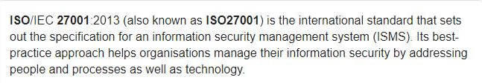
- 4.3.9:
a) As the AS11 DPP Specification only allow up to 127 characters into the MXF header for QC information, is it possible the QC solution can deliver sidecar XMLs or PDFs files for the QC reports?

4.3.9 | Live Quality Check Tool
4.3.9.1 | A tool that will quality check live content during ingest and generate embedded metadata of errors found within the captured clip. |  | 10 | 10
RFP Answer:
Yes, sidecar XML with the MXF if necessary into the PAM of the News Production system.
AS11 DPP is not mentioned as a required specification in the document, it is a great standard for programme delivery not necessarily for Live Ingesting of content for a News Production System; 99% of the content that the NPS will ingest will be live video and files generated internally within the SABC. The majority of the content is raw material which still needs to be edited.
- 4.3.9:
b) Can we get confirmation if all media has to comply to the AS11 DDP Spec (UK)? Will this includes the generation of line-up and metadata.
http://www.sabc.co.za/sabc/wp-content/plugins/download-attachments/includes/download.php?id=2630

RFP Answer:
AS11 DPP is not mentioned as a required specification in the document, it is a great standard for programme delivery not necessarily for Live Ingesting of content for a News Production System; 99% of the content that the NPS will ingest will be live video and files generated internally within the SABC. The majority of the content is raw material which still needs to be edited.

- Can we get confirmation if SDI feeds will be SD or HD and if SD everything will need to be upconverted to HD?

RFP Answer:
We requested the NPS I/O to be ST2110 and although ST2110 is format agnostic we prefer working with the EBU 1080i/25 standard because our storage standard will be AVCIntra100.
Whatever happens within the NPS does not necessarily need to be ST2110 but the Input and Output must be ST2110. We should not restrict the inner workings of the NPS to ST2110, but I/O definitely.
Yes the current infrastructure is HD/SDI EBU 1080i/25 and the bidder is to supply the converters to convert HD/SDI to 2110 and 2110 to HD/SDI as part of their solution. The only request that was made in the briefing was the SABC supply the PTP signal to the I/O for ST2110 synchronisation.
- Additional request please:
Pictures of the front and rear of the racks,
RFP Answer: Pictures of Server room racks, available racks & of racks themselves,
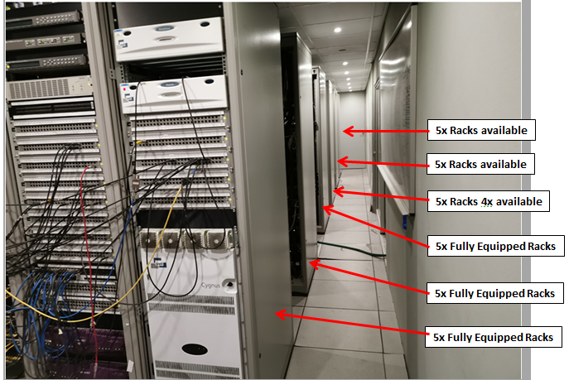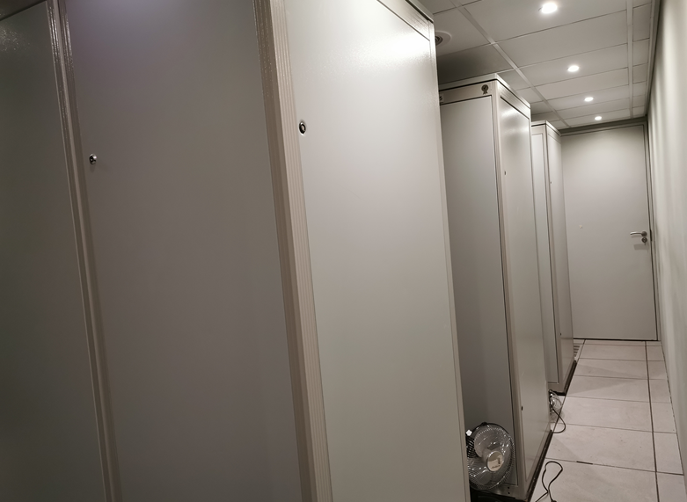
Available Racks
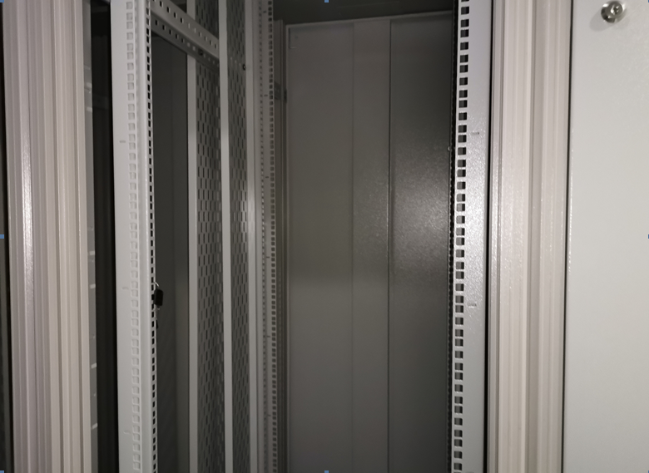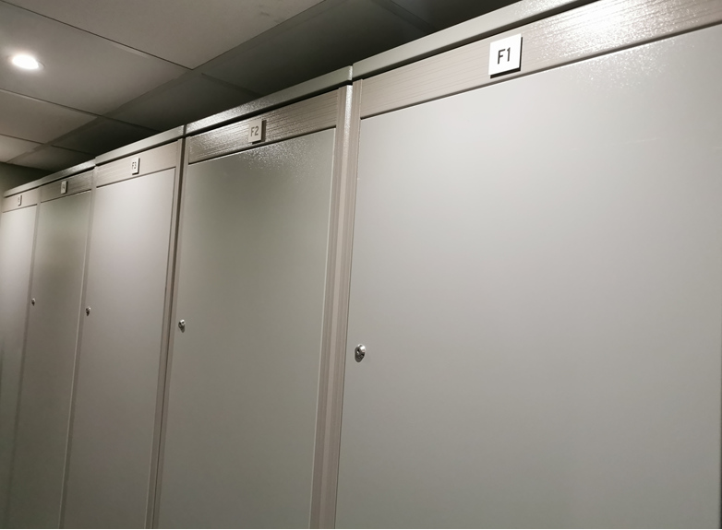
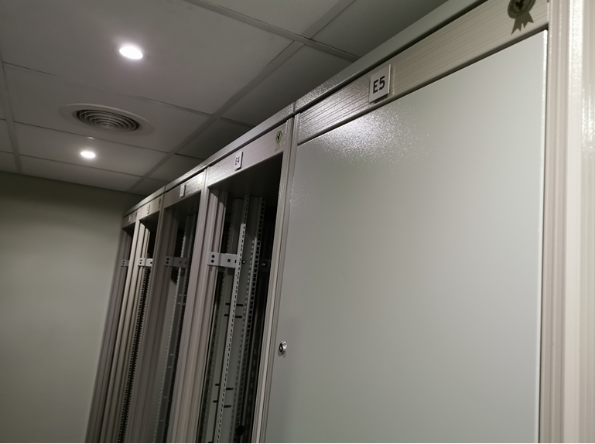

- Pictures of some of the Cut/Cut Edit suites,

RFP Answer: Pictures of two Cut-Cut edit suites – note no external video monitor is required for the Cut editors
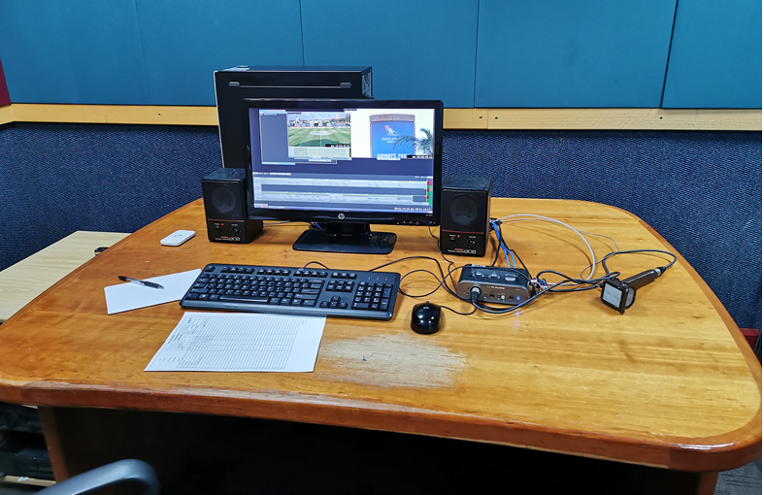
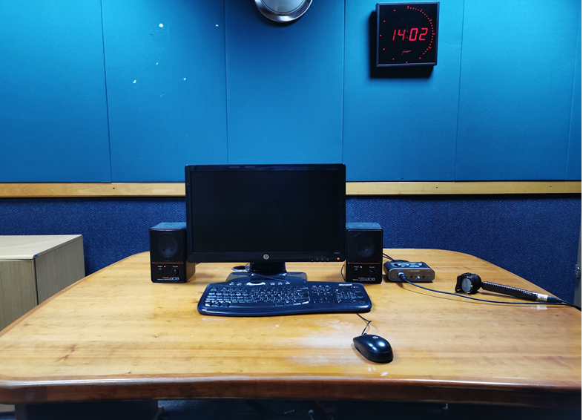

- A floor plan drawing floor 3 newsroom studios, control rooms, edit suites and ingest operator areas,
Please could you provide a floor plan for 3rd FLOOR which will show layout for CAR, edit suites, Studios, Control Rooms
This will assist for installation, cable runs etc. etc. when quoting accurately on this portion of the bid(s)

RFP Answer:
Due to the unavailability of the Drawing Office a pdf drawing will be sent through 7 October 2020.
It may be necessary to indicate cable paths. And indicate that LRR uses a KVM Switch which is based in LRR

- 4.3.7.2:
“Ability to modify ingest parameters while recording”.
Please advise on parameters
RFP Answer:
When a Recording is done, parameters need to be changed;
Most often when it is a crash record of a live unplanned event is done information for the metadata needs to be filled in afterwards. If an allocated time of 30min needs to be extended to 60mins it must be possible, if the category or any other parameters need to be changed or audio channels dropped it must be possible.

- 4.10:
“System Resilience and Reliability”
Are edit suites required here as well?
RFP Answer:
No there is more than one edit suite and it is not the core system which can have a storage access and I/O impact. But systems that can impact all the edit suites for e.g. the floating licenses, the license servers or the proxy media access for the edit suites etc. must have resilience.

- 4.8.1.4.1 Media rights allocation, The media manager must have the ability to provide: time to live setups etc.
Require more details on this requirement. Kindly clarify the purpose

4.8 | Production Asset Management
 | The solution requires the following functionality to aid system searches, user and media management, access control, workflow orchestration and housekeeping;
4.8.1 | Media Management will require the following:
4.8.1.4 | Media rights allocation
4.8.1.4.1 | The media manager must have the ability to provide:  - access control to media;  - user group access, read only access  - and time to live setups etc. Clarity |  | 10 | 10

RFP Answer:
The purpose is that some media rights have an expiry date or a 30 day usage agreement or can only be used in a time period allocated, having a means to alert editorial and editing staff via the metadata, should it be required is a requested functional requirement.

- 4.8.3.1
The system must have the ability to define operating procedures in a value chain to streamline the automated workflows
Require more details on what workflows do the customer want to automate, how many users, etc. ?
RFP Answer:

- 4.9.3.1 The ability to access the News content on the LTO archive database

is Legacy migration required? If yes, how many hours of data do they currently have? How can we access the metadata? Will it be possible for customer to provide us an XML for metadata for all the existing files. We would need this info to register the files in Viz One, to allow users to search & access content stored on LTO tapes
RFP Answer:
No, Legacy migration is another project in the process of development. The only access required is the Archived Content on the LTO via the Masstech integration. The Masstech integration needs to open the data share via the management software. Refer to the RFP.
4.9.3 | The Dalet Galaxy and LTO Masstech (Black Pearl) Archive

The SABC has implemented the Dalet Galaxy as an ingest system for the SABC’s program content. Dalet Galaxy delivers files and archives to the LTO via the Masstech and Black Pearl system. SABC News uses the Dalet Galaxy system to catalogue and archive its media to LTO system.
The NPS is required to enable the following to allow seamless editing where all the content will be managed efficiently, securely, and safely on file-base workflows.
The solution provided by the bidder needs to allow:
4.9.3.1 | The ability to access the News content on the LTO archive database |  | 10 | 10
4.9.3.2 | The ability to search stored content in the Archive (LTO) |  | 10 | 10
4.9.3.3 | The ability to edit the available proxy content of the Active Archive (LTO) |  | 10 | 10
4.9.3.4 | Partial retrieval of content (Hi-res) from the Archive LTO |  | 10 | 10
4.9.3.5 | The ability to push content to Dalet Galaxy for cataloguing and archival purposes |  | 10 | 10
4.9.3.6 | The above functionality must use the same NPS Editing user interface. |  | 10 | 10

- 4.9.3.5 The ability to push content to Dalet Galaxy for cataloguing and archival purposes
What is the current workflow around Galaxy? Will be better if we can have more details on the current operations
RFP Answer:
The current NPS (Quantel) & Dalet workflows:
From the News Production System to the Dalet Galaxy System is simply an automated script which triggers the edited content with the “ARCHIVE” category from the Quantel to export via the file transcoders which wraps (MXF OP1A-codec IMX30) it and deposits it onto a FTP server. From there the script pushes it into the Dalet in-box watch-folder.
Files from the Dalet System are currently also exported to Quantel via the FTP server and deposits the file/s the FTP servers Dalet-out folder. The software script pushes the content from the Dalet-out folder on the FTP server to the Quantel system to be ingested.
The workflow is currently functional but needs to be more slightly more seam-less, hence the request.
4.9.3 | The Dalet Galaxy and LTO Masstech (Black Pearl) Archive

The SABC has implemented the Dalet Galaxy as an ingest system for the SABC’s program content. Dalet Galaxy delivers files and archives to the LTO via the Masstech and Black Pearl system. SABC News uses the Dalet Galaxy system to catalogue and archive its media to LTO system.
The NPS is required to enable the following to allow seamless editing where all the content will be managed efficiently, securely, and safely on file-base workflows.
The solution provided by the bidder needs to allow:
4.9.3.1 | The ability to access the News content on the LTO archive database |  | 10 | 10
4.9.3.2 | The ability to search stored content in the Archive (LTO) |  | 10 | 10
4.9.3.3 | The ability to edit the available proxy content of the Active Archive (LTO) |  | 10 | 10
4.9.3.4 | Partial retrieval of content (Hi-res) from the Archive LTO |  | 10 | 10
4.9.3.5 | The ability to push content to Dalet Galaxy for cataloguing and archival purposes |  | 10 | 10
4.9.3.6 | The above functionality must use the same NPS Editing user interface. |  | 10 | 10

- 4.9.5.1 Search Social Media Platforms
what is meant by 'Search social media platforms'?
RFP Answer:
The question is how do you search social media on-line platforms, or how would you search tags, hashtags or keywords for e.g. on twitter or Facebook etc.? what tools do you propose to be part of you solution to enable the required functionality.
4.9.5 | Incorporation of Social Media tools
 | Media gathering, editing and graphics facilities requires the ability to:
4.9.5.1 | Search Social Media Platforms |  | 5 | 5
4.9.5.2 | Edit available content |  | 5 | 5
4.9.5.3 | Publish to online media platforms |  | 10 | 10

- 4.9.8.1 AVID Mounting/Watch Folder
More details required here for what kind of integration is expected from Avid? What is the current workflow around Avid?
RFP Answer:
Export/Push files to Avid – retrieve files pushed or exported from AVID.
4.9.8 | Broadcast server integration
 | Bidder to indicate your proposed solutions to connect to external storages via mapping and/or mounting (mounting is the ability of a system to incorporate the storage as its own) to enable transfers integrating for the following SABC Broadcast Media Servers:
4.9.8.1 | AVID  Mounting = 2 points or  Watch Folder = 1 point |  | 2 | 1

- Are we defiantly integrating with Avid, if so what version?
RFP Answer:
The RFP asks for “proposed solutions to connect to external storages” “to enable transfers”
As requested version numbers:
- Avid Interplay V3.5
- Interplay Assist V3.5.1
- Media Composer V8.5.3
- Pro-tool V12
- ISIS Client to mount workspace - ISIS Client V4.7.11
4.9.8 | Broadcast server integration
 | Bidder to indicate your proposed solutions to connect to external storages via mapping and/or mounting (mounting is the ability of a system to incorporate the storage as its own) to enable transfers integrating for the following SABC Broadcast Media Servers:
4.9.8.1 | AVID  Mounting = 2 points or  Watch Folder = 1 point |  | 2 | 1

- 4.9.8.2 OMNEON - Media Grid, Mounting /Watch Folder
Same as above. Is MediaGrid used only as storage? What are the ingest and playout servers used currently?
RFP Answer:
The RFP asks for “proposed solutions to connect to external storages” “to enable transfers”
Yes Media Grid is used for Playout Storage System only.
Export/Push files to Media Grid – retrieve files pushed or exported from Media Grid.
4.9.8 | Broadcast server integration
 | Bidder to indicate your proposed solutions to connect to external storages via mapping and/or mounting (mounting is the ability of a system to incorporate the storage as its own) to enable transfers integrating for the following SABC Broadcast Media Servers:
4.9.8.2 | OMNEON - Media Grid,  Mounting = 2 points or  Watch Folder = 1 point |  | 2 | 1

- 4.9.8.3 EVS Mounting/ Watch Folder
Same as above. Need more details
RFP Answer:
The RFP asks for “proposed solutions to connect to external storages” “to enable transfers”
Export/Push files to EVS – retrieve files pushed or exported from EVS.
4.9.8 | Broadcast server integration
 | Bidder to indicate your proposed solutions to connect to external storages via mapping and/or mounting (mounting is the ability of a system to incorporate the storage as its own) to enable transfers integrating for the following SABC Broadcast Media Servers:
4.9.8.3 | EVS  Mounting = 2 points or  Watch Folder = 1 point |  | 2 | 1

- 4.9.8.4 SCISYS dira! Mounting/ Watch Folder
Integrate with Scisys Dira! For audio archive? What kind of integration is expected?
RFP Answer:
The RFP asks for “proposed solutions to connect to external storages” “to enable transfers”
Export/Push files to SCISYS Dira! – retrieve files pushed or exported from Dira!.
Nothing in the RFP requested Audio Archive integration because the Dira! System is used as a Radio Playout system.
4.9.8 | Broadcast server integration
 | Bidder to indicate your proposed solutions to connect to external storages via mapping and/or mounting (mounting is the ability of a system to incorporate the storage as its own) to enable transfers integrating for the following SABC Broadcast Media Servers:
4.9.8.4 | SCISYS dira!  Mounting = 2 points or  Watch Folder = 1 point |  | 2 | 1

- 2x Multiscreen (MS smooth stream encoding)
- Do we know how much Proxy content we will need to process per day, 16 ingest studio ingest, file ingests and contributions from reporters,
- What interplay version is present for news editors for content to be check in, catchup editing while ingest. Also Media composer version and Avid web services version in place.

Also refer to Question 2) answer & 3) answer
RFP Answer:
Nothing in the RFP requested Multiscreen (MS smooth stream encoding).
Most Production Systems due to the volume of simultaneous editing use a low-resolution media (Proxy) which is in synch with their high-resolution media to edit with. When the system ingests any media it is required to generate two simultaneous growing media files for high-res (AvcIntra100) and low-res (Proxy which could be H264/Mpeg4);
To answer the proxy capacity question a):
- we require 16 live ingests – obviously 16x 24/7 not to be restricted
- we also requested a minimum of 4 simultaneous transcoders for file transcoding – obviously 24/7 not to be restricted
- with the ingest server of 2000 Hours capacity and the coupling of all the required edit suites
- please do the sums to capacitate it.
To answer b):
News has their own News Production System (this Solution) and Craft editing facilities (Adobe Production Premiere/FCP) and they only require AVID if they were to Audio Final Mix (Pro-tools) their programmes.
There is no interplay or Media Composer or AVID web Services at News but the News producers have access to AVID if they book an edit facility or Audio final mix facility at the Henley AVID facilities.
4.2 | Core Production Storage
4.2.2 | The core ingest server requires a minimum of 2000 hours of work-in-process HD media content at MXF OP1a AVC-Intra100. |  | 40 | 40
4.2.5 | High- and Low-Resolution media is key for multiple editing sessions – the solution must accommodate low and high resolution editing capability according to the network bandwidths; (indicate the formats recommended) |  | 6 | 6

- will we get support from vendors like Dalet, Masstech, Adobe, for the Newsroom and Graphics Systems?

RFP Answer: The Bidder is to negotiate support directly with the OEM SABC (Newsroom Computer System, Dalet Galaxy, Masstech, Adobe, Graphics Systems) products to ensure integration is achieved and is supported for the life of the implemented solution.
Integration will be the sole responsibility of the Bidder who needs to negotiate with the OEM of these systems to integrate the infrastructure, functionality and workflows required as specified in the RFP. All related integration cost (licensing, development and so on) between the Bidders offered solution and OEM products at the SABC must be included in the proposal. The Bidder will be responsible for the bilateral and any other agreement for the offered solution and the OEM product integration, i.e. the SABC will only contract with the successful Bidder supplying the integrated solution.

